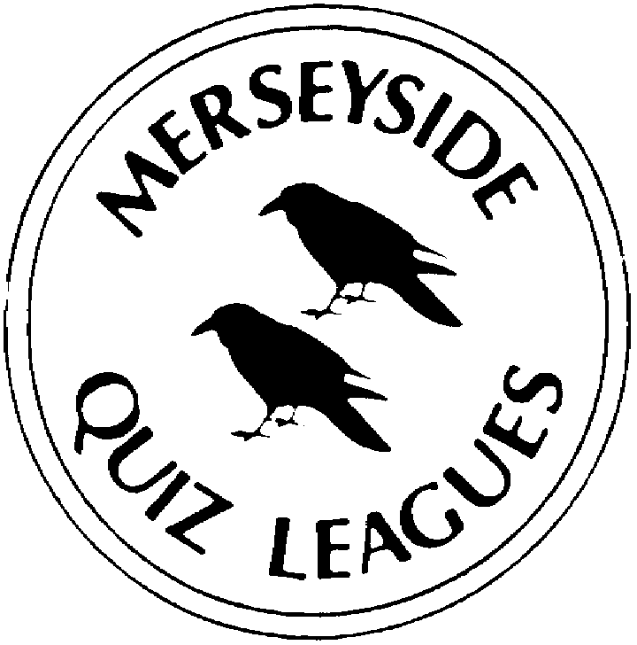 | MERSEYSIDE QUIZ LEAGUES  Questions set by Jack  For use in MIMIR MQL Heats April 2022  Correct as at March 2022

Round One
1a | Which landlocked region in the South Caucasus, internationally recognized as part of Azerbaijan, is a territory that has been disputed by Armenia? | NAGORNO-KARABAKH
1b | Danish actor Claes Bang rose to international recognition in 2020 by starring as which fictional character in a BBC/Netflix horror series? | (COUNT) DRACULA
1c | The national flag of which European country consists of a horizontal tricolour of (from top to bottom) yellow, green and red? | LITHUANIA
2a | Which Gilbert and Sullivan comic opera is a satire on the aesthetic movement of the 1870s and '80s in England? | PATIENCE
2b | Which three-word Latin term means in the act of committing an offence? | IN FLAGRANTE DELICTO
2c | What is the alternative five letter name of the tree also known as the trembling poplar? | ASPEN
3a | In 1988 which UK national newspaper launched an annual Sportswoman of the Year Award? In 2021 the winner was Emma Raducanu. | SUNDAY TIMES
3b | Ørsted A/S, the multinational power company formerly known as DONG and the world's largest developer of offshore wind power is headquartered In which country? | DENMARK
3c | Which dish traditionally eaten in Greece, Turkey and the Balkans, consisting of alternate layers of minced lamb, aubergines and tomatoes, is usually covered with béchamel sauce and cheese? | MOUSSAKA
4a | Opened in July 2002, which museum in Greater Manchester was designed by architect Daniel Libeskind? | IMPERIAL WAR MUSEUM NORTH
4b | In 2020 the UK government department for International Development was incorporated into which other department? | FOREIGN (& COMMONWEALTH) OFFICE
4c | Bertha Mason and Grace Poole are characters in which nineteenth century novel? | JANE EYRE

Round Two
1a | The Tank Museum is a collection of armoured fighting vehicles at which military base in Dorset? | BOVINGTON (CAMP)
1b | In the UK government department abbreviated to BEIS, headed by Kwasi Kwarteng, for what do the letters ‘IS’ stand? | INDUSTRIAL STRATEGY
1c | In which nineteenth century novel does Dorothea Brooke have a loveless marriage to the Reverend Edward Casaubon? | MIDDLEMARCH
2a | Parts of which region in south-east Ukraine are contested by the separatist groups the Donetsk People's Republic and the Luhansk People's Republic? | DONBASS
2b | Blaskó was the real surname of which Hungarian-American actor who portrayed Count Dracula in a 1931 film? | BELA LUGOSI
2c | Which European country has a flag that is almost identical to that of the Netherlands but for the bottom band of the horizontal tricolour being a lighter blue? | LUXEMBURG
3a | In which Gilbert and Sullivan comic opera has a fairy been banished from fairyland because she married a mortal? | IOLANTHE
3b | Which two-word rhyming Latin term means willingly or unwillingly or willy-nilly? | NOLENS VOLENS
3c | What is the alternative five letter name of the tree also known as the mountain ash? | ROWAN
4a | In 1962 who was the first woman to win the BBC Sports Personality of the Year award? | ANITA LONSBROUGH
4b | Which Danish company was the largest container shipping line and vessel operator in the world from 1996 until 2021 until overtaken by the Mediterranean Shipping Company? | MAERSK
4c | Which word from the Persian for ‘taste’ means a selection of small dishes served as appetizers in much of West Asia, the Balkans and Greece? | MEZE (Mazzeh, Mezze or Mazza)

Round Three
1a | At the BBC Sports Personality of the Year ceremony the award given “for outstanding achievement in the face of adversity” is named after which presenter? | HELEN ROLLASON
1b | Which Russian majority state-owned multinational energy corporation headquartered in Saint Petersburg is ranked as the largest company in Russia by revenue? | GAZPROM
1c | If you were served with keftedes in Greece or albondigas in Spain what would you be eating? | MEATBALLS
2a | Britain’s largest aviation museum, a branch of the Imperial War Museum, is based near which village in Cambridgeshire? | DUXFORD
2b | The UK government department formerly known as Housing, Communities and Local Government added which two-word term when Michael Gove became Secretary of State in September 2021? | LEVELLING UP
2c | Which nineteenth century novel was first published as a 19-volume monthly serial with the subtitle Pen and Pencil Sketches of English Society before being published as a single volume with the subtitle A Novel without a Hero? | VANITY FAIR
3a | Transnistria is an unrecognised breakaway state internationally recognised as part of which country? | MOLDOVA
3b | Which British actor starred as the title character in Bram Stoker's Dracula, the 1992 film directed by Francis Ford Coppola? | GARY OLDMAN
3c | The national flag of which European country is a tricolour featuring three equal horizontal bands of (from top to bottom) blue, black and white? | ESTONIA
4a | In which Gilbert and Sullivan comic opera does a young man named Alexis invite the proprietor of J. W. Wells & Co to brew a love potion? | THE SORCERER
4b | Which two-word alliterative Latin term is an artistic or symbolic trope acting as a reminder of the inevitability of death? | MEMENTO MORI
4c | What is the common two-word name of the ornamental tree Salix babylonica? | WEEPING WILLOW

Round Four
1a | With music by Sir Arthur Sullivan and a libretto by Julian Sturgis, which 1891 romantic opera was based on an 1819 novel? | IVANHOE
1b | Which three-word Latin term means an indispensable and essential action, condition, or ingredient? | SINE QUA NON
1c | Araucaria Araucana is known as the Monkey Puzzle tree and also by which other two-word name? | CHILEAN PINE
2a | Irish jockey Rachael Blackmore has won the Grand National, the Champion Hurdle and the Cheltenham Gold Cup riding horses trained by whom? | HENRY DE BROMHEAD
2b | Which oil and gas exploration and production company founded in 2007 and headquartered in Bamber Bridge intend to develop shale gas in the UK by using hydraulic fracturing? | CUADRILLA
2c | Which popular Greek fast food consisting of small pieces of meat and sometimes vegetables grilled on a skewer is usually eaten straight off the skewer while still hot? | SOUVLAKI
3a | Which national collection in Leeds, was originally housed in the Tower of London? | ROYAL ARMOURIES
3b | In the UK government department abbreviated to DCMS, headed by Nadine Dorries, for what does the letter ‘D’ stand? | DIGITAL (Digital, Culture, Media and Sport)
3c | The title of which nineteenth century novel is a fictional town based on the Cheshire town of Knutsford? | CRANFORD
4a | Abkhazia is a de facto state in the South Caucasus, recognised by most countries as part of which country? | GEORGIA
4b | Which 1922 silent German film, subtitled ‘A Symphony of Horror’, starred Max Schreck as Count Orlok in an unauthorized adaptation of Bram Stoker's novel Dracula? | NOSFERATU
4c | The flag of which European country is a tricolour consisting of three equal-sized horizontal bands of (from top to bottom) white, green, and red? | BULGARIA

Round Five
1a | On which Channel 4 dating game show is a clothed person faced with six nude people who are initially hidden in booths? | NAKED ATTRACTION
1b | What is the stage name of George Mpanga, the spoken-word artist and rapper? | GEORGE THE POET
1c | Which SI unit is defined as one newton per square metre? | PASCAL
2a | Who plays Jeremiah "Jimmy" Jesus, a Jamaican born street preacher, in the BBC drama series Peaky Blinders? | BENJAMIN ZEPHANIAH
2b | In which film franchise did Leslie Nielsen play the role of Detective Sergeant. Franklin "Frank" Drebin? | NAKED GUN
2c | Which unit of pressure is approximately equal to 14.5 pounds per square inch? | BAR
3a | Also called American valve and named after a company founded in 1844 which type of pneumatic tyre valve is used on virtually every motor vehicle in the world today? | SCHRADER
3b | Which official poet of the 2012 London Olympics has been chancellor of the University of Manchester since 2015? | LEMN SISSAY
3c | Who wrote the 1959 novel ‘The Naked Lunch’? | WILLIAM S BURROUGHS
4a | Released in 1988 Naked is the eighth and final studio album by which American rock band fronted by Scottish-born David Byrne? | TALKING HEADS
4b | The barye is the unit of pressure on which system of units, a variant of the metric system? | CGS (Centimetre-Gram-Second)
4c | In 2021, who delivered her poem "The Hill We Climb" at the inauguration of U.S. President Joe Biden? | AMANDA GORMAN

Spare Questions
1 | The National Waterways Museum, operated by the Canal & River Trust, is in which town? | ELLESMERE PORT
2 | Who wrote the 1948 novel The Naked and the Dead? | NORMAN MAILER
3 | Which two-word alliterative Latin term means ‘after childbirth’? | POST PARTUM

Tie Break 1
1 | In 1971 members of the Awami League set up a government-in-exile and declared which modern day country an independent state? | BANGLADESH
2 | In which country are traffic lights known as robots? | SOUTH AFRICA
3 | The credits of which writer include the ITV drama series Scott & Bailey, , Happy Valley and the BBC series Last Tango in Halifax and Gentleman Jack? | SALLY WAINWRIGHT

Tie Break 2
1 | What name is given to a coarse, green-skinned banana used as a staple food in tropical countries? | PLANTAIN
2 | What is the capital of the Caribbean country Grenada? | ST GEORGE’S
3 | Which Dutch woman is the current head coach of the England women's national football team? | SARINA WIEGMAN

Tie Break – nearest wins
1 | According to Encyclopaedia Britannica, what is the maximum depth in feet of Lake Baikal, the world’s deepest lake? | 5,315

