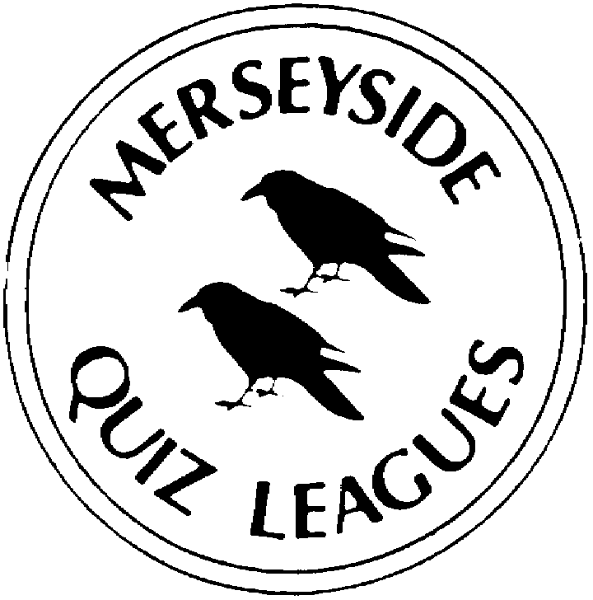 | MERSEYSIDE QUIZ LEAGUES  Questions set by Mike  For use in MIMIR MQL Heats April 2022  Correct as at XXXX

Round One
1a | In which 2003 film, directed by Sofia Coppola. does Bill Murray play a fading American movie star who travels to Tokyo to promote Suntory whisky? | LOST IN TRANSLATION
1b | In 2001 the mills in which river valley in Derbyshire became a UNESCO world heritage site? | DERWENT
1c | Australian born cricketer Sir George Oswald Browning Allen who captained England in eleven Test matches was known by which forename, a play on his initials? | GUBBY
2a | Which 1935 novel by C S Forester features the characters Charles Allnut and Rose Sayer? | THE AFRICAN QUEEN
2b | American Josephine Cochrane was the inventor of the first commercially successful version of which appliance under the name of Lavadora, later changed to Lavaplatos? | (AUTOMATIC) DISHWASHER
2c | Which gold coin was first struck in a former Italian Republic from 1252 to 1533? A British coin with the same name was issued from 1849 until 1967. | FLORIN
3a | Which sock puppet anthropomorphic sheep was created by American puppeteer and ventriloquist Shari Lewis? | LAMB CHOP
3b | Which is the largest political party in Russia? It supports the policies of the incumbent president although Putin is its de facto rather than official leader. | UNITED RUSSIA
3c | Avernus was the name of the infernal regions or their entrance in which mythology? | ROMAN
4a | Hidrotic and sudorific are adjectives referring to the production of what in the body? | SWEAT
4b | During his stay in which coastal city in the south of France did Vincent Van Gogh broadened his subject matter to include series of olive trees, wheat fields and sunflowers? | ARLES
4c | Under what stage name did Stephen John Harrington became famous as the lead singer of the new wave synth-pop group Visage? | STEVE STRANGE

Round Two
1a | Horripilation, considered to be a vestigial reflex when under stress etc, is commonly known as what? | GOOSE BUMPS/  PIMPLES/FLESH
1b | A 1904–1906 series of oil paintings by Paul Cézanne features which mountain overlooking Aix-en-Provence? | (MONT) SAINTE-VICTOIRE
1c | Strangers in the Night was a 1966 studio album and single by which singer? | FRANK SINATRA
2a | For her film Nomadland who became the second woman to win the Academy Award for best director? | CHLOE ZHAO
2b | Which isolated Scottish archipelago that has had no permanent residents since 1930 became a UNESCO World Heritage site in 1987? | ST KILDA
2c | Which England men’s cricket captain moved to England aged three from Milan? | TED DEXTER
3a | Which 1935 memoir by the Danish author Karen Blixen has sometimes been published under her pen name, Isak Dinesen? | OUT OF AFRICA
3b | American inventor Mary Anderson is popularly credited with devising the first power-operated version of which device for cars and other vehicles in 1903? | WINDSCREEN WIPER
3c | A moidore, meaning literally money of gold from Latin monēta dē aurum. was a former coin from which country? | PORTUGAL
4a | Which dummy, attired in his top hat, tuxedo, and monocle, was a partner of American ventriloquist Edgar Bergen? | CHARLIE MCCARTHY
4b | Which French political party was founded in April 2016 by Emmanuel Macron? | (LA RÉPUBLIQUE) EN MARCHE!
4c | In Greek myth what name was given to the underworld roamed by the souls of the dead? | HADES

Round Three
1a | Albert Saveen (or just "Saveen" as he was known) was a ventriloquist who had fourteen puppet characters including which tiny schoolgirl dummy? | DAISY MAY
1b | Fidesz, led by Viktor Orban. is a right-wing populist and national-conservative political party in which country? | HUNGARY
1c | In Hinduism and Buddhism etc what name is given to a place of perfect peace and happiness, like heaven? | NIRVANA
2a | Eructation, the release of gas from the upper digestive tract through the mouth, is commonly known as what? | BURPING/BELCHING
2b | Which village on the River Seine is best known as the location of Claude Monet's garden and home? | GIVERNY
2c | "Stranger on the Shore", the UK's biggest selling single of 1962, is an instrumental piece written by which clarinettist? | ACKER BILK
3a | Who became the first woman to be nominated twice for the Academy Award for best director? | JANE CAMPION
3b | Which castle on Anglesey is part of the UNESCO World Heritage site known as ‘Castles and Town Walls of King Edward in Gwynedd’? | BEAUMARIS
3c | Which Indian prince and cricket player was the captain of the India's national cricket team during its tour of England in 1946? He also played Test cricket for England in 1932 and 1934. | NAWAB OF PATAUDI (Senior)
4a | A Good Man in Africa, published in 1981, is which Scottish writer’s first novel? | WILLIAM BOYD
4b | British inventor Valerie Hunter Gordon is considered to be the inventor of which product used by new parents? | DISPOSABLE NAPPY
4c | The name of which gold or silver coin of varying values, formerly much used in Europe, was derived from the Late Latin for a duchy? | DUCAT

Round Four
1a | Green Hills of Africa is a non-fiction account of a month on safari in 1933 undertaken by which American novelist? | ERNEST HEMINGWAY
1b | Which lightweight, heat-resistant and strong synthetic fibre was developed by Stephanie Kwolek at DuPont in 1965? | KEVLAR
1c | Which obsolete Spanish gold coin, originally worth 2 pistoles, is remembered due in large part to the influence of historical fiction about piracy? | DOUBLOON
2a | Which English ventriloquist was associated primarily with the dummy Lord Charles? | RAY ALAN
2b | After splitting from the Solidarity Electoral Action coalition in 2001, the Law and Justice party was formed in which country? | POLAND
2c | In Norse mythology Hel, the goddess of death, was one of the children of which trickster god? | LOKI
3a | What is the medical tern for sneezing, the rapid and involuntary expulsion of air from the lungs through the nose and mouth? | STERNUTATION
3b | Toward the end of his life, which French Post-Impressionist painter spent ten years in French Polynesia? | PAUL GAUGUIN
3c | "Stranger in Paradise", a song from the musical Kismet is based on a melody bu which Russian composer? | ALEXANDER BORODIN
4a | For which 2008 film did Kathryn Bigelow become the first woman to win the Academy Award for best director? | THE HURT LOCKER
4b | The UNESCO World Heritage site Giant's Causeway and Causeway Coast is part of which Irish county? | ANTRIM
4c | Affectionately and better known as Plum, which England cricketer born in Trinidad, captained England in ten Test matches before the First World War? | PELHAM WARNER

Round Five
1a | Which paralysing poison extracted from the bark of certain South American trees was used by indigenous tribes to coat the tips of arrows and later used as a muscle relaxant? | CURARE
1b | Yen Sid ("Disney" spelled backwards) is the powerful sorcerer in which 1940 film? | FANTASIA
1c | Which stop-motion children's series created by Otmar Gutmann and Erika Brueggemann focuses on a family of anthropomorphic emperor penguins who live at the South Pole? | PINGU
2a | The title of which 1990 book by Roald Dahl is derived from the name of a reptile of the order Chelonia spelled backwards? | ESIO TROT
2b | Which lectin and a highly potent toxin is produced in the seeds of the castor oil plant? | RICIN
2c | Tux the penguin is the official brand character of which mostly free and open-source operating system kernel? | LINUX
3a | Which penguin, a wanted robber who frequently disguises himself as a chicken, features in the Wallace and Gromit animation The Wrong Trousers? | FEATHERS MCGRAW
3b | In 2018 which sportswoman launching her own beauty line company, called Aneres? | SERENA WILLIAMS
3c | In the 1995 Tokyo subway attack, the Aum Shinrikyo sect released a form of which toxic chemical compound? | SARIN
4a | The seeds of the nux vomica tree are the most common source of which highly toxic, colourless, bitter, crystalline alkaloid? | STRYCHNINE
4b | Elijah Wood voices the penguin Mumble in which 2006 computer-animated musical comedy film? | HAPPY FEET
4c | Since 1986 who has been the Chair and CEO of Harpo Productions? | OPRAH WINFREY

Spare Questions
1 | Which country topped the medal table at the 2022 Winter Olympics? | NORWAY
2 | In 1831 which king created the French Foreign Legion? | LOUIS PHILIPPE (I)
3 | What is the name of the art school of University College London (UCL)? | SLADE

Tie Break 1
1 | Which cricket trophy for Test series played between the West Indies and England men has been replaced by the Richards-Botham Trophy? | WISDEN (TROPHY)
2 | Pen-y-Fan is the highest peak in which UK National Park? | BRECON BEACONS
3 | Which Italian word meaning ‘stained’ or ‘spotted’ is used for an espresso coffee with a shot of foamed milk? | MACCHIATO

Tie Break 2
1 | Which medical term is used for habitual grinding of the teeth? | BRUXISM
2 | Which ice-covered, mountainous island off the coast of Antarctica was the desolate refuge of Ernest Shackleton and his crew in 1916 following the loss of their ship Endurance? | ELEPHANT ISLAND
3 | Which crime writer created Detective Inspector Tom Thorne? | MARK BILLINGHAM

Tie Break – nearest wins
1 | Shane Warne took 708 Test wickets but how many runs did he score in the 145 Test matches he played for Australia? | 3,154

