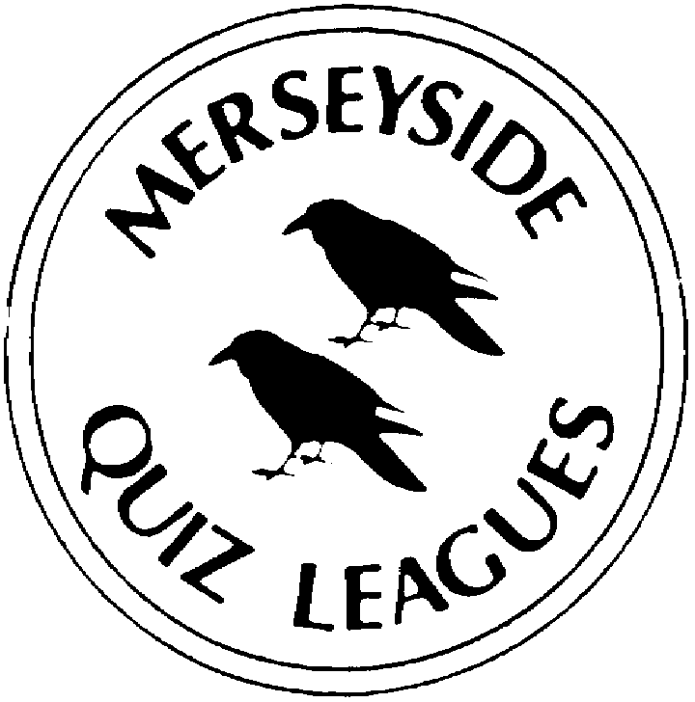 | MERSEYSIDE QUIZ LEAGUES  Questions set by Nora  For use in MIMIR local 2022  Correct as at March 2022

Round 1
1a | Which non-SI unit of length equal to 10⁻¹⁰ m is denoted by an upper case letter from the Swedish alphabet? | ÅNGSTROM
1b | Three male tennis players have won 20 or more Grand Slam singles titles. Who comes next with 14? | PETE SAMPRAS
1c | In a by-election in 2014 Douglas Carswell became the first elected MP for which party, retaining the seat at the 2015 General Election? | UKIP
2a | In 1901 who painted the Beethoven Frieze for the 14th Vienna Secessionist Exhibition? | GUSTAV KLIMT
2b | Who wrote the historical novel The Other Boleyn Girl published in 2001? | PHILIPPA GREGORY
2c | Which sport is played by the Brisbane Broncos and the Canberra Raiders? | RUGBY LEAGUE
3a | The Korfball European Cup has been won by clubs from only two countries - Netherlands and which other? | BELGIUM
3b | When the 88 modern constellations are arranged alphabetically, which comes next- Andromeda, Antlia, Apus, _____________? | AQUARIUS
3c | The Poacher Line Community Rail Partnership promotes a rail route in which English county? | LINCOLNSHIRE
4a | The IMO is a specialised agency of the United Nations responsible for regulating shipping. For what does the M stand? | MARITIME
4b | Which railway station in Somerset has been styled ‘Station of the Glastonbury Festival’ since 2019? | CASTLE CARY
4c | Which cricketer has scored most runs, 15 921, in his test career? | SACHIN TENDULKAR

Round 2
1a | What nationality is singer-songwriter Abel Makkonen Tesfaye, known professionally as The Weeknd? | CANADIAN
1b | What object is shown on the 1929 painting by René Magritte The Treachery of Images together with a quote which translates as “This is not a _______”? | PIPE
1c | Opened in 2014 which UK city has a 14 kilometre tramway that links York Place in the city centre to the Airport? | EDINBURGH
2a | Which current MP was first elected in a by-election in Peckham in October 1982? | HARRIET HARMAN
2b | Nine footballers have won more than 100 caps for England. Which of them was a goalkeeper? | PETER SHILTON
2c | In which 2012 film did Naomie Harris first play Eve Moneypenny? | SKYFALL
3a | Which city is the capital of the German state of Brandenburg? | POTSDAM
3b | The IBRD is the lending arm of the World Bank Group. For what does the R stand? | RECONSTRUCTION
3c | How are Dmitri, Ivan and Alexi described in the title of a novel by Fyodor Dostoevsky published as a serial in 1879-80? | THE BROTHERS KARAMAZOV
4a | “Neither a borrower or a lender be” is a quote from which Shakespeare play? | HAMLET
4b | Which Major League Baseball team has most World Series final appearances? | NEW YORK YANKEES
4c | Who plays Batman in The Dark Knight Trilogy from 2005 to 2012? | CHRISTIAN BALE

Round 3
1a | “All the world's a stage,  And all the men and women merely players” is a quote from which Shakespeare play? | AS YOU LIKE IT
1b | Which city is the capital of the Spanish autonomous community of Aragon? | ZARAGOZA
1c | Joseph and his Brothers is a four-part novel by Thomas Mann in which he retells the story of which book of the Bible setting it in the historical context of the Armana period? | GENESIS
2a | Which of the ossicles of the middle ear is also known as the anvil? | INCUS
2b | Which is the largest city in the French administrative region of Grand Est? | STRASBOURG
2c | UNMISS is a United Nations peacekeeping force established in 2011 in which country? | SOUTH SUDAN
3a | The 2012 film An Unexpected Journey is the first in which trilogy? | THE HOBBIT
3b | The last three studio albums by Canadian rapper Aubrey Graham, Views, Scorpion and Certified Lover Boy have each reached Number 1 in the UK. What is his middle name, by which he is known professionally? | DRAKE
3c | Which candidate under the Anti H-Block label won a by-election in Fermanagh and South Tyrone in April 1981? | BOBBY SANDS
4a | The Believe Tour in 2012-2013 which played over 150 shows worldwide was launched to support which Canadian singer’s third studio album Believe? | JUSTIN BIEBER
4b | Designer Elsa Schiaparelli worked with which surrealist artist to produce the lobster dress worn in a series of photographs in 1937 by Wallis Simpson? | SALVADOR DALÍ
4c | Human sleeping sickness is caused by a bite from which insect? | TSETSE (FLY)

Round 4
1a | A dik-dik is the name for any of four species of which African mammal? | ANTELOPE
1b | What is the family name of the sport playing sisters who became minority owners of the Miami Dolphins in 2009, the first African-American women to take such a role in the NFL? | WILLIAMS
1c | As what was the 2021 United Nations Climate Change Conference usually known? | COP26
2a | Husband and wife Win Butler and Régine Chassagne are members of which Canadian indie rock band? | ARCADE FIRE
2b | There are three Victoria stations in England, in London, Manchester and which Essex resort? | SOUTHEND
2c | The kākā and the hihi are birds native to which country? | NEW ZEALAND
3a | Name and regnal number required. Who was Pope throughout World War Two? | PIUS XII
3b | Four golfers from mainland Europe have captained Europe in the Ryder Cup. Name either of the two who are not Spanish. | BERNHARD LANGER  or THOMAS BJÖRN
3c | Which HBO TV drama that has completed three seasons concerns a family headed by Logan Roy, played by Brian Cox, who own a global media and entertainment company? | SUCCESSION
4a | In Pride and Prejudice by Jane Austen who is the youngest Bennet sister? | LYDIA
4b | In the TV drama Game of Thrones what is the nickname of Sandor Clegane, played by Rory McCann, whose older brother Ser Gregor is known as The Mountain? | THE HOUND
4c | There are 26 Lords Spiritual in the House of Lords, of which five are ex officio, the two archbishops and three bishops. One is the Bishop of London. Name either of the other two. | DURHAM or WINCHESTER

Round 5
1a | And Just Like That ……. is a recent ten episode revival of which romantic comedy TV series that ran for six seasons from 1998? | SEX AND THE CITY
1b | The Head of the Catholic Church in Ireland, the Primate of All Ireland is the Archbishop of __________ where? | ARMAGH
1c | Which action film of 2012 inspired by a 1970s British TV police drama starred Ray Winstone and Ben Drew with Damien Lewis as their boss? | THE SWEENEY
2a | Who played Major Charles Ingram in the 2020 TV drama Quiz? | MATTHEW MACFADYEN
2b | “By the pricking of my thumbs,  Something wicked this way comes.” is a quote from which Shakespeare play? | MACBETH
2c | The successor to Thomas Cranmer in 1556, who was the last Roman Catholic Archbishop of Canterbury? | REGINALD POLE
3a | The Blue Nudes is a series of colour lithographs from 1952 by which artist made from cut-outs depicting nudes in various positions? | HENRI MATISSE
3b | The world’s largest nocturnal primate is which lemur with rodent-like teeth that perpetually grow and a special thin middle finger? | AYE-AYE
3c | “My salad days  When I was green in judgment, cold in blood,  To say as I said then!” is a quote from which Shakespeare play? | ANTONY AND CLEOPATRA
4a | Of the chemical elements whose name begins with A, which is the only one whose symbol does not also begin with A? | ANTIMONY
4b | The sister of former MP for the constituency Jo Cox, who won a by-election in Batley and Spen in July 2021? | KIM LEADBEATER
4c | Which city is the capital of the Italian region of Piedmont? | TURIN

Spare Questions
1 | The Magician’s Nephew and The Last Battle are two of the titles in which series of seven fantasy novels? | THE CHRONICLES OF NARNIA
2 | Tim Canterbury and Dawn Tinsley were characters in which sitcom first broadcast in 2001? | THE OFFICE
3 | Guru Nanak Gurpurab is a festival in which religion? | SIKHISM

Tie Break 1
1 | Rugby League player Fuifui Moimoi was born in Nuku’alofa the capital of which Pacific nation? | TONGA
2 | Eugenius Birch (1818-1884) was an architect and builder of which type of structure in fourteen towns including Margate, New Brighton and Hastings? | PIERS
3 | In which year was Ulysses S Grant elected as US President? | 1868

Tie Break 2
1 | Messiah by Handel was first performed in which city in 1742? | DUBLIN
2 | From 1966 to 1991 SOGAT was a trade union in which industry? | PRINTING
3 | Who won the second Best Actress Academy Award for her first sound film role in Coquette, released in 1929? | MARY PICKFORD

Tie Break – nearest wins
1 | How many elected members are there in the Congress of Deputies, the lower House of the Parliament of Spain? | 350

