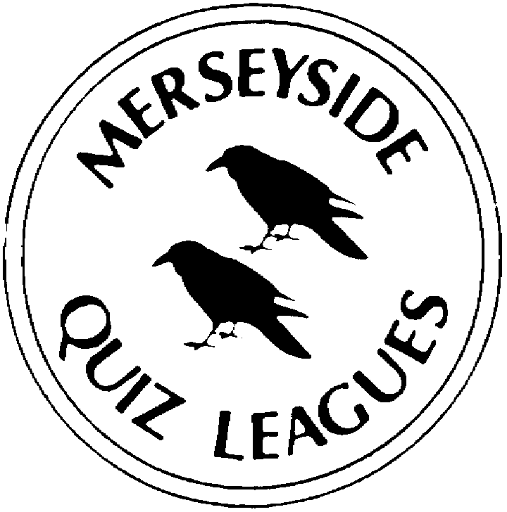 | MERSEYSIDE QUIZ LEAGUES  Questions set by Paul  For use in MIMIR Area Heats on 18 April 2022  Correct as at 15th February 2022

Round 1
1a | Who played the title character in Ken Russell's film Tommy, an adaptation of the rock opera album by the Who? | ROGER DALTREY
1b | Which river, the 13th longest in the UK, flows through the town of Rugby? | AVON
1c | Which Swiss city, scene of a major series of conferences in 1925, stands at the north end of Lake Maggiore? | LOCARNO
2a | The 1971 novel Fear and Loathing in Las Vegas was a work by which creator of gonzo journalism? | HUNTER S THOMPSON
2b | Who became the first English footballer to win FIFA's Best Women's Player of the Year when she won the 2020 award? | LUCY BRONZE
2c | + (pronounced plus) and x (pronounced multiply) are chart topping albums by which singer? | ED SHEERAN
3a | Which scientist first postulated the "Quantum Theory", winning the Nobel Prize in 1918? | MAX PLANCK
3b | Siblings Amelia and Jos Sedley are among the main characters of which novel? | VANITY FAIR
3c | Herve Cheese is traditionally made in which country? | BELGIUM
4a | Ben Bernanke was the head of which American governmental institution from 2006 to 2014? | US FEDERAL RESERVE
4b | Princess Maud, the daughter of King Edward VII, became (through her marriage) Queen consort of which European country? | NORWAY
4c | What to a German is a schuhplattler? | FOLK DANCE (slap dance in lederhosen)

Round 2
1a | Waiting for the Barbarians and Disgrace are works by which novelist? | (John Maxwell) J. M. COETZEE
1b | Which footballer was voted PFA player of the year in both 2020 and 2021? | KEVIN DE BRUYNE
1c | Who recorded Wanted on Voyage one of the best-selling albums of 2014? | EZRA
2a | Jonny Lee Miller played Mr George Knightly in the 2009 BBC adaptation of which Jane Austen novel? | EMMA
2b | Who became the oldest Nobel Prize winner when he jointly won the 2019 Physics award for his work on lithium-ion batteries? | DR JOHN GOODENOUGH
2c | Who created the fictional clergyman Dr Charles Primrose? | OLIVER GOLDSMITH (Vicar of Wakefield)
3a | Entering office on 13th June 2021, Naftali Bennet is the current Prime Minister of which country? | ISRAEL
3b | Kristalina Georgieva became Chair of which international organisation in October 2019? | INTERNATIONAL MONETARY FUND-IMF
3c | Which European country was ruled by two kings called Carol in the 20th century? | ROMANIA
4a | What is the highest peak on Tasmania? | MOUNT OSSA
4b | Jeremy Brett played Freddy Eynsford-Hill in the 1964 film adaptation of which musical? | MY FAIR LADY
4c | On which US river does the city of Albuquerque stand? | THE RIO GRANDE

Round 3
1a | Anna Taylor Joy played Beth Harmon in which acclaimed Netflix mini-series? | THE QUEENS GAMBIT
1b | Which German won the Nobel Prize for Chemistry in 1918 despite having produced poison gases for use in WW1 earning him the soubriquet 'The Father of Chemical Warfare'? | FRITZ HABER
1c | The school bully, Harry Flashman, who was resurrected in a series of novels by George MacDonald Fraser, was originally created in 1857 by whom? | THOMAS HUGHES
2a | Armada is a goat's milk cheese from which country? | SPAIN
2b | Ably Ahmed Ali, who was awarded the 2019 Nobel Peace Prize, is the prime minister of which country? | ETHIOPIA
2c | Since 2021, Mick Lynch has been the General Secretary of which union? | RMT
3a | The German compound noun ‘Hamsterkauf’ (literally ‘hamster purchase’) describes which activity, much in the news recently? | HOARDING OF FOOD
3b | Which 3000-foot-high volcano can be found in the Lipari Islands off Italy? | STROMBOLI
3c | Which 1977 film stars the characters Tony Manero and Stephanie Mangano? | SATURDAY NIGHT FEVER
4a | At the airport of which African city did Israeli commandos storm a hijacked Air France plane in 1976? | ENTEBBE
4b | Who followed up her award-winning debut novel White Teeth published in 2000, with the novels The Autograph Man, On Beauty and NW? | ZADIE SMITH
4c | Which footballer, in 1977, won both the PFA Player of the Year and Young Player of the Year awards? | ANDY GRAY

Round 4
1a | Which south-east Asian country is the world's second-largest exporter of coffee after Brazil? | VIETNAM
1b | Joko Widodo has been president of which south-east Asian country since 2014 | INDONESIA
1c | Dr Robert Anderson, Hartwig Fischer and Neil MacGregor have served as Director of which organisation in the 21st century? | BRITISH MUSEUM
2a | Alexander I who was assassinated in Marseilles in 1934, was king of which country? | YUGOSLAVIA
2b | Fasching Dienstag is known as what in English speaking countries? | SHROVE TUESDAY
2c | Which volcano on the Caribbean Island of Martinique erupted with devastating effect in 1902? | MOUNT PELEE
3a | On which river does the city of Bamako stand? | NIGER
3b | Which American City was devastated by a Fire in 1871? | CHICAGO
3c | Who wrote the 12-volume novel sequence A Dance to the Music of Time? | ANTHONY POWELL
4a | Which noted artist released the 2018 album Rise Up? | CLIFF RICHARD
4b | Which 1977 TV drama, starring Alison Steadman, is set in the living room of Beverly Moss? | ABIGAIL’S PARTY
4c | What is the surname of father and son Niels and Aage, both winners of the Nobel Prize in Physics? | BOHR
Round 5
1a | Which European country was ruled by the Oldenburg dynasty from 1448 to 1863? | DENMARK
1b | The German words Eingang or Einfahrt, means what in English? | ENTRANCE
1c | At 874m high, what is the highest point of the Scottish island of Arran? | GOATFELL
2a | Hugh Jackman played the part of P T Barnum in which 2017 film? | THE GREATEST SHOWMAN
2b | On which major river does Baghdad stand? | TIGRIS
2c | The Black Death, the 14th century outbreak of disease thought to be bubonic plague, reached Britain when a ship from Calais brought it to which Dorset port during the summer of 1348? | MELCOMBE REGIS (accept Weymouth)
3a | Name either of the two strikers were the first players inducted into the Premier League Hall of Fame in April 2021? | ALAN SHEARER or THIERRY HENRY
3b | In 2019 who released the best-selling album Divinely Uninspired to a Hellish Extent? | LEWIS CAPALDI
3c | January Jones played Betty Draper in which TV series from 2007 to 2015? | MAD MEN
4a | Who created the fictional clergyman Obadiah Slope? | ANTHONY TROLLOPE
4b | Which country is the world's biggest producer of Brazil nuts? | BOLIVIA
4c | Tsai Ing-wen won the election, on 11 January 2020, for President of which country? | THE REPUBLIC OF CHINA (accept Taiwan, or Formosa)

Spare Questions
1 | VC Bird International airport is located on which Caribbean Island? | ANTIGUA
2 | Who wrote the 1927 novel Tarka the Otter? | HENRY WILLIAMSON
3 | What was the surname of the musician best known by his forename Prince? | NELSON

Tie Break 1
1 | The film Mullholland Drive is located in which city? | LOS ANGELES
2 | In April 2020 who came second to Keir Starmer in the Labour party leadership election? | REBECCA LONG-BAILEY
3 | Since 2007, which cricketer has been married to the singer Jessica Taylor, a member of the group Liberty X? | KEVIN PIETERSON

Tie Break 2
1 | On 16th February 2021 the post office issued a set of commemorative stamps to mark the 40th anniversary of which sitcom? | ONLY FOOLS AND HORSES
2 | In medieval and Renaissance England, which laws regulated what clothing you could wear according to your position in society? | SUMPTUARY LAW
3 | What term was used under Tsar Nicholas II and under Stalin to describe the richer landowning peasants? | KULAKS
Tie Break – nearest wins
1 | How many goals were scored in football's recent African Cup of Nations held in Cameroon in 2022? | 100

