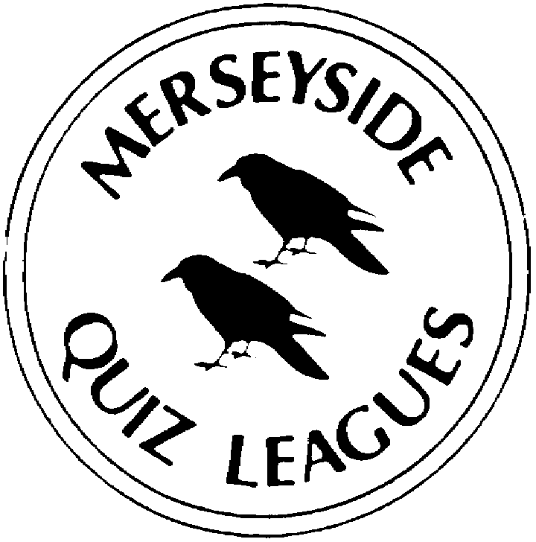 | MERSEYSIDE QUIZ LEAGUES  Questions set by Kiki  For use in MIMIR Merseyside 2022  Correct as at 4 April 2022

Round 1
1a | Who devised the Coast to Coast Walk from St Bees to Robin Hood’s Bay? | ALFRED WAINWRIGHT
1b | Catherine of Aragon was the daughter of King Ferdinand II of Aragon and Queen Isabella I of _________ where? | CASTILE
1c | For which 1965 film did Lee Marvin win a Best Actor Oscar? | CAT BALLOU
2a | Who was the first woman to receive a Nobel Prize, which she shared in 1903? | MARIE CURIE
2b | The Mediterranean island of Lampedusa is part of which country? | ITALY
2c | Which jockey rode the winner of the 2022 Cheltenham Gold Cup? | RACHAEL BLACKMORE
3a | The Wilberforce Way, a 60-mile walking route devised as a tribute to mark the bicentenary of the 1807 abolition of the British Atlantic Slave Trade, runs between York and which city? | HULL
3b | Why were Anna Firth in Southend on Thursday February 3 and Paulette Hamilton in Birmingham on Thursday March 3 in the news this year? | WON BY-ELECTIONS  or BECAME MPs
3c | How many stars are there on Flag painted in 1954-55 by Jasper Johns? | 48
4a | Samuel Smith’s brew Old Brewery Bitter in which North Yorkshire town? | TADCASTER
4b | Which wind god is depicted on the left of the painting The Birth of Venus by Botticelli? | ZEPHYR
4c | Lady Jane Grey claimed the throne from July 10 to July 19 in which year? | 1553

Round 2
1a | Which record label was founded in 1978 by Tony Wilson and Alan Erasmus? | FACTORY (RECORDS)
1b | What is the family name of the father and son who shared the 1915 Nobel Prize in Physics for inventing X-Ray crystallography? | BRAGG
1c | Whose 1938 painting Time Transfixed shows a locomotive jutting out of a fireplace, at full steam, in an empty room with a clock on the mantelpiece and a mirror on the wall above? | RENÉ MAGRITTE
2a | Who voices Alex the Lion in the Madagascar film franchise? | BEN STILLER
2b | In the reign of Mary I three Protestants known as the Oxford Martyrs were burned at the stake. Two of them were Thomas Cranmer, the Archbishop of Canterbury and Bishop Hugh Latimer. Which Bishop was the third? | NICHOLAS RIDLEY
2c | Who was the first Vice President of the USA? | JOHN ADAMS
3a | In Absolutely Fabulous, what was the one-word name of Edina’s personal assistant? | BUBBLE
3b | Which word completes the name of Smith & _________ , a medical equipment manufacturing company listed on the FTSE 100 Index? | NEPHEW
3c | The Greater Sunda Islands are four tropical islands in Southeast Asia. Three are Java, Sumatra and Sulawesi. Which is the fourth? | BORNEO
4a | Which boxer, known as the Leeds Warrior, is the IBF World Featherweight champion, also holding the title from 2018 to 2021? | JOSH WARRINGTON
4b | She was made a Dame in the 2022 New Year Honours - who is the Chief Executive of the UK Health Security Agency and Head of NHS Test and Trace? | JENNY HARRIES
4c | Which US Vice President killed an opponent in a duel when in office in 1804? | AARON BURR

Round 3
1a | Which Liverpool-born athlete won the heptathlon at the 2019 World Athletics Championships? | KATARINA JOHNSON-THOMPSON
1b | In ‘Allo ‘Allo! who owned a ‘little tank’ driven by the unseen Clarence? | LIEUTENANT GRUBER
1c | Mount Teide the highest point in Spain is on which island in the Atlantic Ocean? | TENERIFE
2a | The Camel Trail is a 17.3 mile cycleway in which English county? | CORNWALL
2b | Which comprehensive school is attended by the pupils in the sitcom The Inbetweeners? | RUDGE PARK
2c | When F E Smith was appointed Lord Chancellor in 1919 he became the First Earl of _________ where, his birthplace? | BIRKENHEAD
3a | Name either of the Vice Presidents under US President Abraham Lincoln. | HANNIBAL HAMLIN  or ANDREW JOHNSON
3b | Which was the debut album, released in 1994, by the band Oasis? | DEFINITELY MAYBE
3c | Which species of cat is Baby in the 1938 film Bringing Up Baby? | LEOPARD
4a | Which band was formed in Wilmslow in 2002 by Matthew Healy, Adam Hann, Ross MacDonald and George Daniel? | THE 1975
4b | Which organisation has won the most Nobel Peace Prizes, three, for its humanitarian work? | (INTERNATIONAL COMMITTEE  OF THE) RED CROSS
4c | In which venue can you watch performances at the Joan Sutherland Theatre and the Utzon Room? | SYDNEY OPERA HOUSE

Round 4
1a | Since 1982 the London Symphony Orchestra has been based at which venue? | BARBICAN (CENTRE)
1b | Previously Governor-General, Sandra Mason became the first President of which Caribbean nation last November? | BARBADOS
1c | Give a year in the life of Joseph Smith Junior, founder of Mormonism. | 1805-1844
2a | The Houghton Weavers perform in which genre of music? | FOLK
2b | How are Jean de Dinteville and Georges de Selve described in the title of a 1533 Hans Holbein painting? | THE AMBASSADORS
2c | The Royal Concertgebouw Orchestra is based in which European capital city? | AMSTERDAM
3a | Offred is the narrator of which 1985 novel set in the Republic of Gilead? | THE HANDMAID’S TALE
3b | Name and regnal number required. Which King of Scotland was killed at the 1513 Battle of Flodden Field. | JAMES IV
3c | Struthio camelus and struthio molybdophanes are the two living species of which African bird? | OSTRICH
4a | Which Canadian island is named after a Royal Navy officer who lived from 1757 to 1798? | VANCOUVER ISLAND
4b | Which is the only species of penguin found north of the Equator? | GALÁPAGOS PENGUIN
4c | In which 1899 novel does Charles Marlow tell of his adventures in the Congo to a group of men on a ship anchored in the Thames Estuary? | HEART OF DARKNESS

Round 5
1a | The red-necked avocet (Recurvirostra novaehollandiae) is native to which country? | AUSTRALIA
1b | Which 2003 novel tells the story of Amir, a young boy who lives through a series of tumultuous events in Afghanistan? | THE KITE RUNNER
1c | There are five living former US Vice Presidents. Which one held the office the earliest, from 1989 to 1993? | DAN QUAYLE
2a | What is the binomial name (one word repeated) of the manx shearwater? | PUFFINUS PUFFINUS
2b | Who did John Parrott beat in the final of the 1991 World Snooker Championship, one of his six second place finishes? | JIMMY WHITE
2c | Which 1925 novel concerns Josef K who is arrested one morning and subjected to a judicial process for an unspecified crime? | THE TRIAL
3a | Milton Friedman and John Nash have each won which Nobel Prize? | ECONOMICS
3b | Which word completes the title of the orchestra which performs the annual New Year’s Concert at the Musikverein in Vienna - the Vienna ___________ ? | PHILHARMONIC
3c | Which Southport-born golfer finished second in the 2019 Open Championship? | TOMMY FLEETWOOD
4a | Which long distance footpath runs from Sedbury on the River Wye to Prestatyn? | OFFA’S DYKE PATH
4b | Which cat is played by Judi Dench in the 2019 film Cats? | (OLD) DEUTERONOMY
4c | The theme tune of which sitcom set in an Oxfordshire village was a setting of Psalm 23, composed by Howard Goodall? | THE VICAR OF DIBLEY

Spare Questions
1 | Which legendary bird completes the title of the winning entry in the 2014 Eurovision Song Contest - “Rise Like a __________”? | PHOENIX
2 | Which tinned and boxed chocolates, toffees and sweets was named after the title of a play by J M Barrie? | QUALITY STREET
3 | Name either of the Bond films directed by Sam Mendes. | SKYFALL or SPECTRE

Tie Break 1
1 | Which sculptor who won the Turner Prize in 1994 with Field for the British Isles was knighted in 2014? | ANTONY GORMLEY
2 | Who is Professor of Particle Physics at the University of Manchester and The Royal Society Professor for Public Engagement in Science? | BRIAN COX
3 | The BBC Wales Sports Personality of the Year for 2021 Lauren Price won Olympic Gold in Tokyo in which sport? | BOXING

Tie Break 2
1 | Lake Managua is the second largest lake in which country in the Americas? | NICARAGUA
2 | The six Royal Navy ironclad battleships of the 1880s Collingwood, Anson, Camperdown, Howe, Rodney and Benbow, belonged to which class? | ADMIRAL
3 | Margaret Keenan was the first person (outside trials) to receive a coronavirus vaccine. Who was the first man? | WILLIAM SHAKESPEARE

Tie Break – nearest wins
1 | How many stations are there on the Paris Métro? | 304

