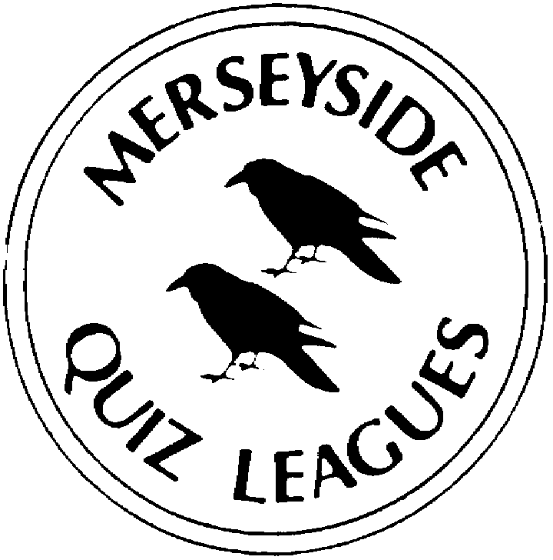 | MERSEYSIDE QUIZ LEAGUES  Questions set by Philip  For use in MIMIR Final 4th May 2022  Correct as April 2022

Round One
1a | Which star because of its distinctive red tint has a name meaning 'rival to Mars'? | ANTARES
1b | Which island nation's flag consists of five bands of blue, yellow, red, white and green emanating from the bottom left, in a fan shape, to the top right? | SEYCHELLES
1c | Walter Mondale was vice-president to which 20th century US President? | JIMMY CARTER
2a | Which French football team play their home matches at the Stade Vélodrome? | OLYMPIQUE DE MARSEILLE
2b | Which celestial object gets its name from the Latin for cloud or fog? | NEBULA
2c | Which island nation's flag consists of four horizontal bands of red, blue, yellow and green? | MAURITIUS
3a | The World of Coca-Cola and the headquarters of CNN are found in which American city? | ATLANTA
3b | Name either Italian football team who play their home matches at the Stadio Luigi Ferraris. | U.C. SAMPDORIA or GENOA C.F.C.
3c | What is the outermost layer of the Sun's atmosphere called? | CORONA
4a | Who created the fictional detectives Nick & Nora Charles? | DASHIELL HAMMETT
4b | Independence Hall and the Liberty Bell are found in which American city? | PHILADELPHIA
4c | Which Spanish football team play their home matches at the Mestalla Stadium? | VALENCIA CF

Round Two
1a | In ‘The Arnofini Portrait’, the 1434 painting by Van Eyck, what object is in the centre of the wall behind the couple? | A CONVEX MIRROR
1b | For which 2016 film did Damien Chazelle win the Oscar for Best Director and Emma Stone win the Oscar for Best Actress? | LA LA LAND
1c | Who, in 1513, led the first European expedition to sight the Pacific Ocean? | (VASCO DE NUNEZ) DE BALBOA
2a | Hubert Humphrey was vice-president to which 20th century US President? | LYNDON B JOHNSON
2b | In David's 1793 painting 'The Death of Marat', what is he holding in his left hand? | LETTER
2c | For which 2017 film did Frances McDormand win the Oscar for Best Actress and Sam Rockwell win the Oscar for Best Supporting Actor? | THREE BILLBOARDS OUTSIDE EBBING, MISSOURI
3a | Which island nation's flag consists of two horizontal bands of red and green with a vertical white band on the hoist side? | MADAGASCAR
3b | Richard Nixon was vice-president to which 20th century US President? | DWIGHT D EISENHOWER
3c | In Rousseau's 1897 painting 'The Sleeping Gypsy' what musical instrument is shown alongside the gypsy? | MANDOLIN
4a | In which constellation is the Crab Nebula? | TAURUS
4b | Which island nation's flag consists of two horizontal bands of red and white with a white crescent and five stars in the upper left? | SINGAPORE
4c | Harry S. Truman was vice-president to which 20th century US President? | FRANKLIN D ROOSEVELT

Round Three
1a | In which year did Auroras Encore win the Grand National, Eleanor Catton’s The Luminaries win the Booker Prize and was Pope Francis elected? | 2013
1b | Founded in Hawick (pronounced Hoyk) in 1815, which British fashion brand specialising in knitted garments, originally socks, is one of the world’s oldest continuously operating fashion companies. | PRINGLE (of Scotland)
1c | Ali Farag is the currently the World Champion in which sport? | SQUASH
2a | Who, in 1606, on board the Duifken, led the first European expedition to site and the land in Australia? | (WILLEM) JANSZOON
2b | In which year did Hedgehunter win the Grand National, John Banville’s The Sea win the Booker Prize and was George W. Bush inaugurated for a second term as US President? | 2005
2c | Which British luxury fashion house was established in 1856 in Basingstoke on the principle that clothing should be designed to protect people from the British weather? | BURBERRY
3a | For which 2010 film did Colin Firth win the Oscar for Best Actor and Tom Hooper win the Oscar for Best Director? | THE KING’S SPEECH
3b | Who, 1541-1543, led the first European expedition to navigate the full length of the River Amazon? | (FRANCISCO) DE ORELLANA
3c | In which year did Comply or Die win the Grand National, Aravind Adiga’s The White Tiger win the Booker Prize and Lehman Brothers declare bankruptcy causing global markets to plummet? | 2008
4a | In the 1768 painting by Joseph Wright of Derby, ‘The Experiment With An Air Pump’, what is inside the glass bowl of the pump? | A BIRD
4b | Which 2013 film won the Oscar for best picture and best supporting actress for Lupita Nyong'o? | 12 YEARS A SLAVE
4c | Name either of the two leaders of the first European expedition who, in 1860-1861, crossed Australia from south to north? | (ROBERT) BURKE or (WILLIAM) WILLS
Round Four
1a | Eleanor of Aquitaine was the mother of two kings of England, name either? | RICHARD I or JOHN
1b | The HQ of the United Nations’ World Food Programme is based in which city? | ROME
1c | Which Radio 2 DJ has presented Rhythm Nation on Saturday evenings since 2016? | TREVOR NELSON
2a | Nelly Korda is the current world number two female player in which sport? | GOLF
2b | Who was the most famous son of Duke Robert the Devil? | WILLIAM I/ THE CONQUEROR
2c | The HQ of Interpol is in which city? | LYON
3a | Described by Vogue magazine as "perhaps the greatest living milliner", the name of which Irish designer is the foremost British brand for meticulously crafted hats | PHILIP TREACY
3b | David Ames is the current captain of the English team in which sport? | HOCKEY
3c | Which king of England was succeeded by three of his children? | HENRY VIII
4a | In which year did One for Arthur win the Grand National, George Saunders’ Lincoln in the Bardo win the Booker Prize and the UK trigger Article 50 of the Lisbon Treaty, beginning Brexit negotiations? | 2017
4b | Which British luxury fashion house was established in 1884 by Lewis Tomalin based on the benefits of clothing made from natural fibres including merino wool, alpaca, and cashmere? | JAEGER
4c | Peter Wright is the current world number one player in which sport? | DARTS

Round Five
1a | Who created the fictional detective Cordelia Gray? | P D JAMES
1b | The Magnificent Mile and Lincoln Park Zoo are found in which American city? | CHICAGO
1c | Which German football team play their home matches at the Volkswagen Arena? | VFL WOLFSBURG
2a | Who took over from Martha Kearney as the main presenter of Radio 4’s Woman’s Hour in January 2021? | EMMA BARNETT
2b | Who created the fictional detectives Tommy & Tuppence Beresford? | AGATHA CHRISTIE
2c | The oldest Chinatown in North America and Fisherman’s Wharf are found in which American city? | SAN FRANCISCO
3a | The HQ of the United Nations’ Educational, Scientific and Cultural Organisation, UNESCO is in which city? | PARIS
3b | Which singer has presented a weekly blues show on Radio 2 and a Sunday morning show on Radio 6 Music? | CERYS MATTHEWS
3c | Who created the fictional detective Mike Hammer? | MICKEY SPILLANE
4a | Who, 1377, was created the first Duke of Cornwall? | EDWARD, THE BLACK PRINCE
4b | The headquarters of the International Olympic Committee is in which city? | LAUSANNE
4c | Which scientist and broadcaster presents Radio 4’s The Life Scientific? | JIM AL-KHALILI

Spare Questions
1 | Tenera is the Spanish word for which meat? | VEAL
2 | Which Irish writer spent time in Walton Prison in 1939 before being sentenced to 3 years in Borstal for attempting to set off a bomb in Liverpool docks while aged just 16? | BRENDAN BEHAN
3 | In Seurat's 1886 painting 'Sunday Afternoon on the Island of La Grande Jatte' what animal does the lady in the right foreground have on a leash? | MONKEY
Tie break One
1 | Name the type of insect that belongs to the order Dermaptera. | EARWIG
2 | Who created the fictional detective Inspector Wallander? | HENNING MANKELL
3 | Who, in 1488, led the first European expedition to round what is now the Cape of Good Hope but which he called the Cape of Storms? | (BARTOLOMEU) DIAS
Tie Break Two
1 | Which island nation's flag consists of a red field with a white rectangle in the top left-hand corner on which is a short armed red cross? | TONGA
2 | Paul Bayes resigned as Anglican Bishop of Liverpool in March 2022, of where was he Bishop before coming to Liverpool in 2014? | HERTFORD
3 | Which Regiment of British Foot Guards has tunic buttons arranged in groups of two and has a red plume in the right side of their bearskin? | COLDSTREAM
Tie Break – nearest wins
 | To the nearest foot, what was the length of RMS Titanic? | 883ft

