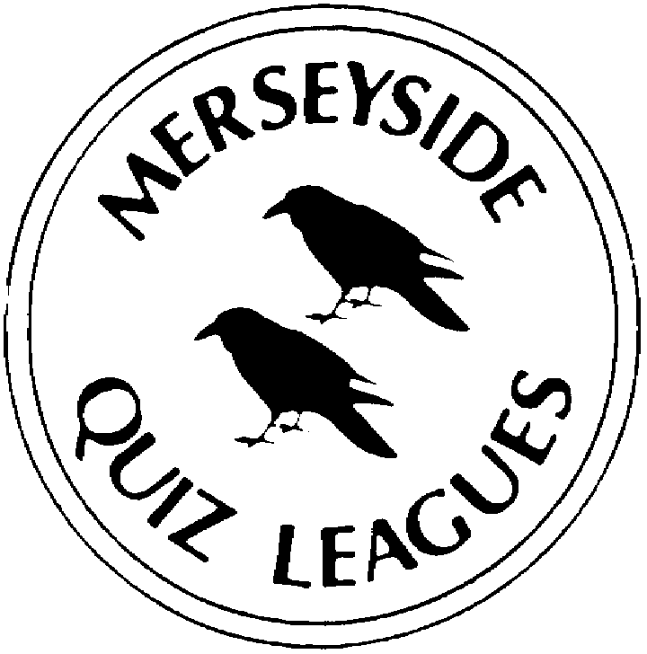
MQLOnline

 | Home Team: |  |  |  |  |  |  |  |  |  |  |  |  |  |  |  | Away Team:
 | No 1 |  | No 2 |  | No 3 |  | No 4 |  | Rnd |  | Tot |  |  |  |  |  | No 1 |  | No 2 |  | No 3 |  | No 4 |  | Rnd |  | Tot
1 |  |  |  |  |  |  |  |  |  |  |  | Date: |  |  |  | 1
2 |  |  |  |  |  |  |  |  |  |  |  |  |  |  |  | 2
3 |  |  |  |  |  |  |  |  |  |  |  |  |  |  |  | 3
4 |  |  |  |  |  |  |  |  |  |  |  |  |  |  |  | 4
5 |  |  |  |  |  |  |  |  |  |  |  |  |  |  |  | 5
6 |  |  |  |  |  |  |  |  |  |  |  |  |  |  |  | 6
7 |  |  |  |  |  |  |  |  |  |  |  |  |  |  |  | 7
8 |  |  |  |  |  |  |  |  |  |  |  |  |  |  |  | 8
Please check
Player Totals
= Match Total

First Name |  | Surname |  | First Name |  | Surname
1 |  |  |  | 1
2 |  |  |  | 2
3 |  |  |  | 3
4 |  |  |  | 4
 | Did you go first/second? |  |  |  | Did you go first/second?

Question Person:_________________________

Captain:_____________________________________ Captain:_____________________________________

Do player totals equal match totals?
Checklist
Have you indicated which team went in first?

