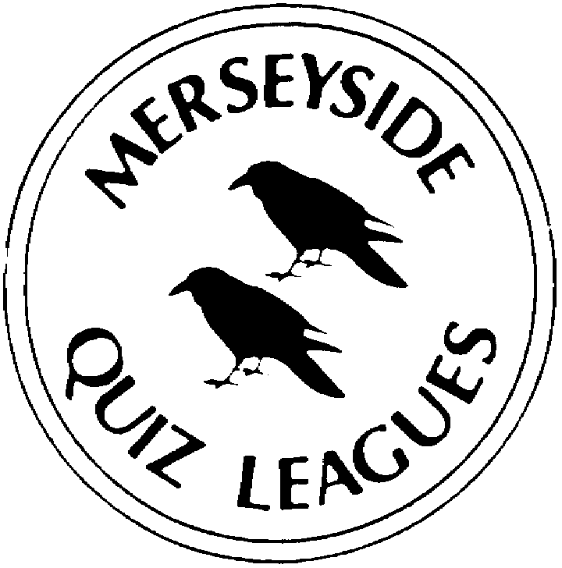 | MERSEYSIDE QUIZ LEAGUES  Questions set by Dimmy  For use in Mimir individual competition heats  Correct as at 17th February 2022

Round 1
1a | Whose symphony No 2-nicknamed “The 4 Temperaments” was first performed in 1902? | CARL NIELSEN
1b | In the 2021 Tokyo Summer Olympics- Team GB’s 1st medal was won by Chelsie Giles-in which sport? | JUDO
1c | Eddie Vedder is lead singer of which U.S rock band? | PEARL JAM
2a | After China and India which is the largest Asian country in terms of population? | INDONESIA
2b | Who was the architect of London’s Millennium Bridge and Wembley Stadium? | NORMAN FOSTER
2c | Who is the youngest winner of a Nobel Prize at the age of 17? | MALALA YOUSAFZAI(2014)
3a | Who won Baseball’s World Series in 2021? | ATLANTA BRAVES(accept either name)
3b | Which comedian and cricket enthusiast took over as chair of Radio 4’s “The News Quiz” in 2020? | ANDY ZALTZMAN
3c | Which war was ended by the Treaty of Ghent in 1814? | THE GREAT BRITAIN/USA WAR-accept WAR OF 1812
4a | Which element’s name is derived from the Greek words for against and alone?-Its atomic number is 51 | ANTIMONY
4b | David Brock is the only remaining member of which British progressive rock band?-their biggest hit was their 1972 top 10 single “Silver Machine” | HAWKWIND
4c | In terms of population-which is Europe’s 2nd largest country after Russia? | GERMANY

Round 2
1a | Who directed the 1950 film Sunset Boulevard? | BILLY WILDER
1b | Who is the only person to win more than one unshared Nobel Prize? | LINUS PAULING(1954/1962)
1c | Which trophy is awarded to the winning team in the NFL Superbowl? | VINCE LOMBARDI TROPHY
2a | Which war was ended by the Treaty of Portsmouth in 1905? | RUSSO JAPANESE WAR
2b | Billie Joe Armstrong is the lead singer of which U.S rock band? | GREEN DAY
2c | Who directed the 1952 film High Noon? | FRED ZINNERMAN
3a | The Masai or Tanzanian is the largest species of which animal? | GIRAFFE
3b | In terms of area-which is Europe’s 2nd largest country after Russia? | UKRAINE
3c | Which Asian car manufacturer makes the Niro model? | KIA
4a | Who composed “The Symphony of Sorrowful Songs” first performed in 1977? | HENRYK GORECKI
4b | Which comedian’s Radio 4 show takes place in his “Imaginary Sandwich Bar”? | ALEXEI SAYLE
4c | Plains and Mountain are 2 of the 3 types of which large animal? | ZEBRA(Grevy’s is the 3rd)

Round 3
1a | Which war was ended by the Treaty of Aix la Chappelle in 1748? | WAR OF THE AUSTRIAN SUCCESSION
1b | After Algeria which is Africa’s largest country in terms of area? | DEMOCRATIC REPUBLIC OF THE CONGO
1c | To which family of animals does the badger belong? | MUSTELIDAE(Mustelids)
2a | In the 2021 Tokyo Summer Olympics-at which sport did Sky Brown become Team GB’s youngest ever medallist? | SKATEBOARDING
2b | Which Canadian team has won the NHL Stanley Cup a record 24 times? | MONTREAL CANADIENS(accept either name)
2c | Which U.S. state is nicknamed the Badger State? | WISCONSIN
3a | Who composed the Symphonia Domestica first performed in 1904? | RICHARD STRAUSS
3b | Which element’s name is derived from the Greek word for lead?-Its atomic number is 42 | MOLYBDENUM
3c | What is the better known name for the London building with the address 30 St Mary Axe? | THE GHERKIN
4a | Which Asian car manufacturer makes the Ioniq model? | HYUNDAI
4b | Which war was ended by the Treaty of Paris in 1763? | SEVEN YEARS WAR
4c | The United States has won the most Nobel Prizes in each category except for Literature-which country holds that record? | FRANCE

Round 4
1a | Which Asian car manufacturer makes the Forester model? | SUBARU
1b | In which Radio 4 programme-hosted by David Mitchell- do panellists score points for spotting surprisingly accurate assertions during other contestant’s wildly untrue “lectures”? | THE UNBELEIVABLE TRUTH
1c | In electronic components a transistor can be described as a BJT-what does the B stand for? | BIPOLAR(Junction Transistor)
2a | Which large animal has Javan,Sumatran,Black and White species? | RHINOCEROS
2b | Which Asian car manufacturer makes the CX-60 model? | MAZDA
2c | Which element’s name is derived from the Greek word for ray or beam? Its atomic number is 89 | ACTINIUM
3a | In the 2021 Tokyo Summer Olympics-Emily Campbell became Team GB’s first female medallist in which sport? | WEIGHTLIFTING
3b | Who directed the 1954 film On The Waterfront? | ELIA KAZAN
3c | Steven Tyler is the lead singer of which U.S rock band? | AEROSMITH
4a | What is the name of the device in which electrons are made to resonate in a chamber to produce radiation-they are frequently used in microwave ovens? | MAGNETRON
4b | Which is the tallest building in London? | THE SHARD(accept London Bridge Tower)
4c | In the 2021 Tokyo Summer Olympics-Hannah Mills was flag bearer for Team GB-she won a gold medal in which sport? | SAILING

Round 5
1a | Which is Africa’s largest antelope? | (GIANT) ELAND
1b | Who was the architect of London’s Millennium Dome and Lloyd’s Building? | RICHARD ROGERS
1c | Which element’s name is derived from the Greek words for hard to get at?--its atomic number is 66? | DYSPROSIUM
2a | Whose symphony No3 nicknamed “The Kaddish” was first performed in 1963? | LEONARD BERNSTEIN
2b | Who replaced Humphrey Lyttleton as permanent chairman of the Radio 4 panel game “I’m sorry I haven’t a clue”? | JACK DEE
2c | Its name derived from a Greek word for “flow” or “stream”-which electrical device is used to control a current by varying the resistance? | RHEOSTAT
3a | Who was the first person to voluntarily decline the award of a Nobel Prize? | JEAN PAUL SARTRE(1964)
3b | In the UK-badgers have been culled in an effort to limit the spread of which disease? | (BOVINE) TUBERCULOSIS
3c | In electronic components-a transistor can be described as an FET-what does the F stand for? | FIELD(effect transistor)
4a | David Lee Roth was the leader of which U.S. rock band? | VAN HALEN
4b | Which is the only non-USA team competing in the NBA? | TORONTO RAPTORS(accept either name)
4c | Who directed the 1951 film The African Queen? | JOHN HUSTON

Spare Questions
1 | Who is the reigning Flat racing Champion Jockey? | OISIN MURPHY
2 | In which town/city will the next Winter Olympic Games be held? | CORTINA/MILAN(accept either)
3 | Who recorded the UK’s best-selling single of 2021? | ED SHEERAN(Bad Habits)

Spare Questions
1 | Who is the reigning National Hunt racing Champion Jockey? | HARRY SKELTON
2 | In which city will the Summer Olympics of 2028 take place? | LOS ANGELES
3 | Who recorded the UK’s best-selling album of 2021 | ADELE(30)

Spare Questions
1
2
3

Tie Break – nearest wins
1 | According to the UK Office for National Statistics what was the population of Merseyside at the last census ? | 1,434,256

