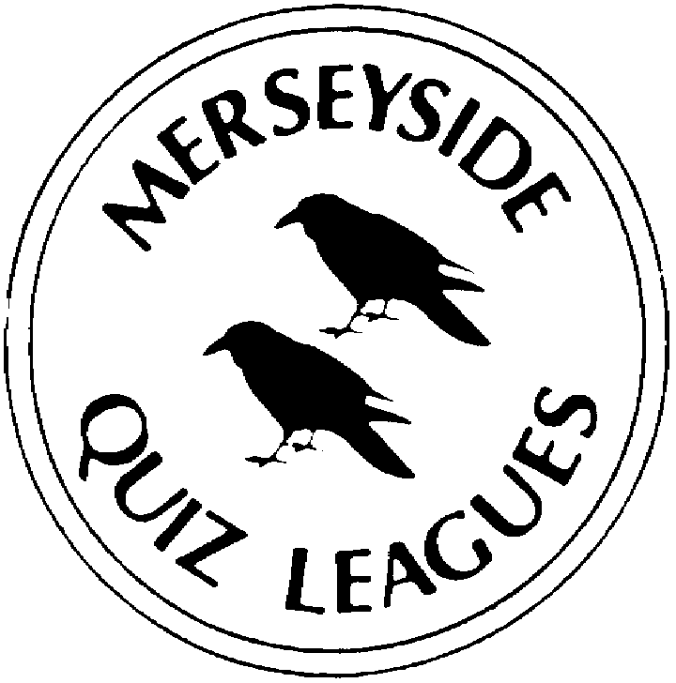 | MERSEYSIDE QUIZ LEAGUES  Questions set by Peggy  For use in MIMIR Local Heats on 20 April 2022  Correct as at March 2022

Round 1
1a | The firm of Boots the Chemist and Raleigh Bicycles originated in which English city? | NOTTINGHAM
1b | Which Dickensian title character was the son of Agnes Fleming but was given his name by Mr Bumble? | OLIVER TWIST
1c | Which British tree is a member of the Olive and Lilac family? It contains over 60 species, is deciduous and has varieties known as European, White and Black. | ASH
2a | In 1993 Norman Foster and Associates won the contract to design and reconstruct the Dome atop which parliament building in a European capital city. The glass Dome, originally controversial, is now one of the landmarks of the city. | THE REICHSTAG (in Berlin)
2b | What was the surname of the US lyricist Harold or Hal who died aged 91 in 2012? His songs include Walk on By, Close To You and Do You Know the Way to San Jose. | DAVID
2c | Who created the work that is a depiction of a naked woman with her back to the viewer, who is admiring herself in a mirror held by a winged infant? It is in the collection of the National Gallery in London. | VELASQUEZ (The Toilet of Venus)
3a | Which structure that was opened in London in 2000 was found to exhibit synchronous lateral excitation? | THE (THAMES) MILLENIUM FOOTBRIDGE
3b | What name is given to the acid which builds up during anaerobic exercise and can hinder the performance of athletes? | LACTIC
3c | The camera follows a white feather drifting on the breeze until it lands at the feet of the title character at the beginning of which 1994 film? He picks it up, puts it into a child's story book in his suitcase and starts to talk to the person alongside him. | FORREST GUMP
4a | What is the name of the historic region of Greece that contains the country's capital, Athens? It is a peninsula projecting into the Aegean Sea. | ATTICA
4b | What name is given to the knife with a rounded tip and no edge used for cooking and serving? | PALETTE (KNIFE)
4c | Which crowned monarch of England reigned for the longest period In the 13th century? | HENRY III

Round 2
1a | The Scottish Distilleries of Cardhu and Glenfiddich are based in which Scottish River Valley? | SPEY
1b | What name is given to the document cases on each side of the table down the centre of the House of Commons that are used as lecterns? | DESPATCH BOXES
1c | According to the title of an 1834 work by Hector Berlioz in which country was Harold to be found? | ITALY
2a | Which period of English history and artistic style is named for the return to the throne of Charles II in 1660? | RESTORATION
2b | In 1999 a media centre with a revolutionary single shell aluminium design was opened at which London sports venue? | LORDS
2c | What is the name of the acid which is the synthetic form of the substance also known as vitamin B9? It helps create new red blood cells and is particularly important during pregnancy? | FOLIC
3a | In the 20 tennis majors played since the start of 2017, only 2 men have broken the singles dominance of Federer, Djokovic and Nadal. Name one of these players. | DANIIL MEDVEDEV, DOMINIC THIEM
3b | What two-word name is given to the cooking device consisting of a bowl placed over a pan of simmering water? | BAIN MARIE
3c | What is the name of the state or land of Germany that has its capital at Dresden and includes Colditz Castle, Leipzig and Chemnitz? | SAXONY
4a | In 2019, which domestic electrical appliance manufacturer moved its HQ from Malmesbury in Wiltshire to Singapore? | DYSON
4b | Which Dickensian title character was named Amy and spent her time earning money to look after her father, a long-term inmate of the Marshalsea prison? | LITTLE DORRIT
4c | Which tree found in lowland Britain, often along streams and small rivers, can have varieties called Black, Grey, Green and White? | ALDER

Round 3
1a | Who created the work of art that depicts a bare breasted young woman carrying a flag, clambering over fallen comrades and leading other men all of whom are carrying weapons? The background is smoke filled. It is in the collection of the Louvre. | DELACROIX (Liberty Leading the People)
1b | Which churchman who fell from favour with Henry VIII died in 1530, having failed to secure Henry’s divorce from Catherine of Aragon? | WOLSEY
1c | The Golden Jubilee footbridges, opened in 2002, lie either side of the Hungerford Bridge which carries rail traffic across the Thames into which mainline London station? | CHARING CROSS
2a | Which 1965 film begins, with the camera panning across mountains and beautiful scenery before picking up a young woman walking across an alpine meadow? It swoops in as she sings. | THE SOUND OF MUSIC
2b | Max Whitlock successfully defended which Olympic title in Tokyo 2020 (2021) | (Men's) POMMEL HORSE
2c | Sharing its name with a musical instrument, what name is given to the device which can be used to cut several thin strips of vegetables or other items in a single action? | MANDOLIN
3a | In which English city are the UK headquarters of the firms Jet2, First Direct Bank and Asda Stores Limited? | LEEDS
3b | Which Dickensian title character was married twice, firstly to Dora Spenlow and then to Agnes Wickfield? | DAVID COPPERFIELD
3c | Which crowned monarch of England reigned for the shortest period In the 16th century? | MARY I
4a | EU regulations require that the spirit Brandy be produced exclusively from which fruit? | GRAPE
4b | What name is given to the upper house of the French and several other national parliaments? | SENATE
4c | What was the surname of the much-admired US theatre director Harold or Hal who died in 2021? His works include the original productions of Evita, Sweeney Todd and The Phantom of the Opera. | PRINCE

Round 4
1a | What is the name of the principal acid that is responsible for the low pH in the human stomach? | HYDROCHLORIC
1b | Which 2016 film begins as the camera pans along miles of standing traffic on a US freeway before focussing in on a female driver who is singing? She gets out of the car and is soon joined by other drivers dancing between and on top of the cars. | LA LA LAND
1c | Who won his second golf major when he became the 2021 Open Champion? | COLLIN MORAKAWA
2a | Which English shoe manufacturer's headquarters and main factory was for many years to be found in Street in Somerset? | CLARKS
2b | What is the name of the most north-westerly autonomous community of mainland Spain? Its capital is Santiago de Compostela, and it is noted for its architecture and Atlantic coast holiday resorts? | GALICIA
2c | Which crowned monarch of England reigned for the longest period In the 11th century? | EDWARD THE CONFESSOR
3a | Which coniferous tree growing in Britain can have varieties called Siberian, European and Japanese? | LARCH
3b | Which French wine producing area is centred around the city of Reims and the town of Epernay? | CHAMPAGNE
3c | What name is given to the organ of the United Nations which has a representative from every member nation? | THE GENERAL ASSEMBLY
4a | Who created the work of art that is the depiction of the crucifixion but viewed from above looking down on the crucified Christ? It is in the collection of the Kelvingrove Museum in Glasgow. | DALI (Christ of St John of the Cross)
4b | Which battle of 1485 effectively brought the end of the Plantagenet dynasty and the War of the Roses? | BOSWORTH FIELD
4c | Marks Barfield, named for the two lead architects, were the firm responsible for which London landmark opened in 1999? | LONDON EYE
Round 5
1a | What is the name of the most populous region of Belgium? It contains the Albert Canal linking Liege and Antwerp and the Brussels-Capital Region? | FLANDERS (accept FLEMISH REGION)
1b | Which kitchen utensil is known as a skillet in the US? | FRYING PAN
1c | Which crowned monarch of Britain reigned for the shortest period In the 19th century? | WILLIAM IV
2a | Which Dickensian title character had friends called Newman Nogs and Smike and an uncle called Ralph? | NICHOLAS NICKELBY
2b | Which British tree is a genus of about 35 species cultivated for their height and attractive appearance? There are varieties known as the Cedar, Chinese and the American. | ELM
2c | According to its label, which spirit is distilled in Lynchberg Tennessee? | JACK DANIELS
3a | What was the surname of Harry or Hal, the US film producer and director of silent and early sound comedy films who in 1921 first paired Laurel and Hardy? | ROACH
3b | Who created the work of art that shows two young boys sitting on the seawall at Budleigh Salterton in Devon while an old man tells them stories and points out to sea? It is in the collection of the Tate Britain. | MILLAIS (The Boyhood of Raleigh)
3c | Which 18th century British monarch was the last of the house of Stuart? | ANNE
4a | What name is given to the organic acids that combine to form proteins? Nine of these acids are described as essential to the human body and are obtained from food digestion. | AMINO
4b | Which 1959 film begins as a hearse moves sedately through Chicago? As sirens sound the hearse accelerates and is chased by police cars. Many gunshots are exchanged and when the hearse come to a halt, whiskey begins to pour out of the holes in the coffin. | SOME LIKE IT HOT
4c | Adam Peaty successfully defended which Olympic title in Tokyo 2020 (2021) | (Men's) 100m BREASTSTROKE

Spare Questions
1 | What is the name of the building that houses the Parliament of the Republic of Ireland? | LEINSTER
2 | Which team lost the 2019 FA Cup final six nil to Manchester City one of the largest winning margins in the history of the finals | WATFORD
3 | In the BBC shipping forecast, which is the southernmost of the 31 sea areas? | TRAFALGAR

Tie Break 1
1 | The presenter Ben Shephard is associated with which daytime quiz/gameshow? | TIPPING POINT
2 | In July, the delayed 2021 World Athletics Championships will be held in the US for the first time. In which city in Oregon? | EUGENE
3 | The Christian feast of Pentecost can fall in two months, name either of them. | MAY OR JUNE

Tie Break 2
1 | In 1971, which UK prime minister was the first to be featured on a British £5 bank note? | WELLINGTON (Arthur WELLESLEY)
2 | Along with Queen’s Bench and Chancery, the third division of the UK High Court? | FAMILY
3 | Situated on the Deccan Plateau, what is the capital of the Indian state of Karnataka? | BANGALORE (BENGALURU)
Tie Break – nearest wins
 | How much did a UK first class stamp for a 60g letter cost 20 years ago today in 2002? | 27p

