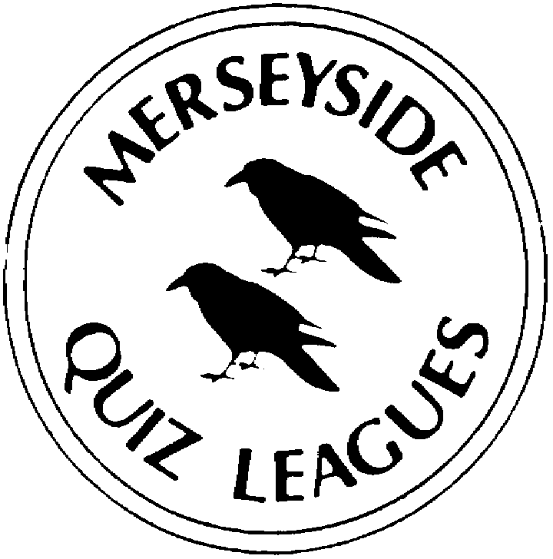 | MERSEYSIDE QUIZ LEAGUES  Based on questions set by Lucy-Ann  For use in MIMIR Merseyside Heats on 27 April 2022  Correct as of 25 April 2022

Round 1
1a | Named after its inventor, which skin test was developed in 1913 to determine whether or not a person was susceptible to diphtheria? | SCHICK
1b | Humourist H M Bateman created a series of cartoons featuring comic over-reactions to social gaffes. The title of each began with which three words? | THE MAN WHO …
1c | In which book of the Bible is the story of Samson and Delilah? | JUDGES
2a | The title role in the 1970 film The Man Who Haunted Himself produced a critically well received performance by which English TV and film star? | ROGER MOORE
2b | The LMC is a satellite galaxy of the Milky Way nearly 200,000 light years from Earth. It is named for which famous explorer | MAGELLAN (The Large Magellanic Cloud)
2c | In which book of the Bible is the story of Nebuchadnezzar? | DANIEL
3a | After its inventor, which name was given to the ‘pineapple’ shaped hand grenades used by the British Army in World Wars I and II. | MILLS bombs
3b | Which book of the Bible tells of the death of Moses? | DEUTERONOMY
3c | Dev Patel played Srinivasa Ramanujan in the 2015 film The Man Who Knew … which mathematical concept? | INFINITY
4a | The Man Who Had All The Luck was the title of a 1944 play by which US writer? | ARTHUR MILLER
4b | Which book of the Bible tells the story of David and Goliath? | SAMUEL
4c | Which species of penguin is named after the wife of the French Antarctic explorer, Jules Dumont d’Urville? | ADELIE

Round 2
1a | Based on the name of a large nearby seaside town, which repeated letters form the two-letter postcode for areas of Conwy, Colwyn Bay and Rhyl? | LL
1b | … But Seriously, the UK’s best-selling album in 1990, was by which artist? | PHIL COLLINS
1c | Which US President commissioned several custom-made bathtubs because of his size? In 1915 one of them overflowed and flooded a hotel dining room below. | WILLIAM HOWARD TAFT
2a | Based on the name of a nearby city, which two successive letters of the alphabet form the postcode for areas of Alfreton, Burton-on-Trent and Matlock? | DE
2b | Escapology, the UK’s best-selling album in 2002, was by which artist? | ROBBIE WILLIAMS
2c | When he was the Sheriff of Erie County, which person who would become US President in 1885, also acted as the hangman? | GROVER CLEVELAND
3a | Based on the name of a nearby city, which two successive letters of the alphabet form the postcode for areas of Alsager, Kidsgrove and Newcastle-under-Lyme? | ST
3b | Our Version Of Events, the UK’s best-selling album in 2012, was by which artist? | EMELI SANDE
3c | Which US President died in 1850, when he became violently ill after  eating a large bowl of cherries and other fruits? | ZACHARY TAYLOR
4a | Based on the name of a large nearby seaside city, which repeated letters form the two-letter postcode for areas of Basildon, Westcliffe-on-Sea and Canvey Island? | SS
4b | Divinely Uninspired To A Hellish Extent, the UK’s best-selling album in 2019 and 2020, was by which artist? | LEWIS CAPALDI
4c | Taking office in 1809, who was the only other US President besides George Washington to have signed the US constitution? | JAMES MADISON

Round 3
1a | Which artist painted, American Gothic in 1930? | GRANT WOOD
1b | Of the countries who have won the FIFA Men’s World Cup, which is the only country besides England to have won it on only one occasion? | SPAIN
1c | In the present UK government, who is the Secretary of State for Digital, Culture, Media and Sport? | NADINE DORRIES
2a | Of the English football clubs who have won the European Cup/European Champions League, which has won it on only one occasion? | ASTON VILLA
2b | In the present UK government, who is the Secretary of State for Education? | NADHIM ZAHAWI
2c | Which artist painted, Persistence of Memory in 1931? | SALVADOR DALI
3a | Of the countries who have won the FIFA Women’s World Cup, which is the only one from outside of Europe and North America? | JAPAN
3b | Which artist painted, Starry Night in 1888? | VINCENT VAN GOGH
3c | In the present UK government, who is the Secretary of State for Health & Social Care? | SAJID JAVID
4a | Which artist painted Nighthawks in 1942? | EDWARD HOPPER
4b | In the present UK government, who is the Secretary of State for Defence? | BEN WALLACE
4c | Of the 15 countries who have won the African Cup of Nations in Men’s football, which country with 7 wins has done so on most occasions? | EGYPT

Round 4
1a | Who discovered electromagnetic induction, which led to the invention of the dynamo? | MICHAEL FARADAY
1b | What is the name of the company that operate ferry services from the mainland to over 20 of the islands off Scotland’s west coast? | CALEDONIAN MACBRAYNE (accept CALEDONIAN or MACBRAYNE or CALMAC)
1c | Given a year either way, name the year in which Gunther von Hagens performs a public autopsy in London, the Imperial War Museum North opens in Salford Quays, and Princess Margaret and the Queen Elizabeth, the Queen Mother both die. | 2002 (2001 – 2003)
2a | Who was the Frenchman who in the seventeenth century, laid the foundations for the modern theory of probabilities? | BLAISE PASCAL
2b | The A3 road runs from the Elephant and Castle in London to the outskirts of which city? | PORTSMOUTH
2c | Given a year either way, name the year in which the United Reform Church of England and Wales is formed, John Betjeman becomes the Poet Laureate and the Duke of Windsor, the former Edward VIII dies in Paris. | 1972 (1971 – 1973)
3a | Who helped revolutionise the knowledge of atomic structure by his discovery of the electron in 1897? | J.J. THOMSON
3b | Which British airport with the IATA designation LBA is the hub for the Jet2 airline and was formerly known as Yeadon? | LEEDS BRADFORD (prompt on either offered singly)
3c | Given a year either way, name the year in which Crick and Watson announce the discovery of the structure of DNA, Winston Churchill wins the Nobel Prize for Literature and Queen Mary, the wife of King George V dies. | 1953 (1952 – 1954)
4a | Who became known as the “Father of Nuclear Physics” and won the Nobel Prize for Chemistry in 1908? | ERNEST RUTHERFORD
4b | What is the name of the parent company who operate TransPennine Express and Great Western Railways | FIRST (GROUP)
4c | Given a year either way, name the year in which John Logie Baird made the first TV transmission of a moving image, Austen Chamberlain won the Nobel Prize for Peace and Queen Alexandra, the wife of King Edward VII died. | 1925 (1924 – 1926)

Round 5
1a | In Geometry, what name is given to a point where two or more lines or edges meet? | VERTEX
1b | Set in a Jewish home in North London, which Channel 4 sitcom ran from 2011 to 2020 and starred Tamsin Greig and Paul Ritter | FRIDAY NIGHT DINNER
1c | Which Booker Prize winning author was also shortlisted in 2003 for the novel Oryx and Crake? | MARGARET ATTWOOD
2a | Set in Reynholm Industries, a fictional British company, which Channel 4 sitcom ran from 2006 to 2013 and starred Richard Ayoade (EYE-OH-ADAY) and Chris O’Dowd? | THE IT CROWD
2b | Which Booker Prize winning author was also shortlisted in 2005 for the novel On Chesil Beach? | IAN MCEWAN
2c | What name is given to the middle value of a list of numbers put in  order from the smallest to the largest? | MEDIAN
3a | Which Booker Prize winning author was also shortlisted in 2005 for the novel Never Let Me Go?? | KAZIO ISHIGURU
3b | The mantissa is the name given to the digits following a decimal point in what type of number in mathematics? | LOGARITHM
3c | Set in a run-down mansion Button House and its grounds, which BBC1 sitcom that began in 2019 stars Charlotte Ritchie and Kiell Smith-Bynoe? | GHOSTS
4a | Set in Danebury, North Essex, which BBC4 sitcom ran from 2014 to 2017 and starred Mackenzie Crook and Toby Jones? | DETECTORISTS
4b | Although she is yet to win the Booker Prize, which author was shortlisted in 2005 for The Accidental, in 2014 for How To Be Both and in 2017 for Autumn? | ALI SMITH
4c | In Geometry, what name is given to a line drawn within a circle from one point on the circumference to another but does not pass through the centre of the circle. | CHORD

Spare Questions
1 | At the end of November 2021, which country became the world’s newest republic? | BARBADOS
2 | In September 2021, who launched the True and Fair Party, which failed to attract much interest? | GINA MILLER
3 | What was the name of John Cabot’s ship in which he sailed to Newfoundland in 1497? There are modern replicas in Bristol and in Bonavista. | MATTHEW

Tie Break 1
1 | Name the Swedish vessel which sank on its maiden voyage in 1628 in Stockholm harbour? | VASA
2 | Which mountain range is in upper New York State, its highest peak is Mount Marcy? | ADIRONDACKS
3 | In April 2022 Eddie Redmayne and Jessie Buckley won Olivier acting awards for their performances in a revival of which stage musical? | CABARET

Tie Break 2
1 | What was the name of the diver who with Tom Daley won a gold medal in the men’s synchronised 10 metre platform event at the delayed 2020 Tokyo Olympics? | MATTY LEE
2 | Published posthumously in 1681, who wrote the metaphysical poem To His Coy Mistress? | ANDREW MARVELL
3 | Which multinational company owns the brand names Ben and Jerry's ice cream, Colman's Mustard and Marmite? | UNILEVER

Tie Break – nearest wins
1 | According to their own website, what is the height in feet of the Blackpool Tower? | 518.75 feet

